THE
HEFFERNAN
GROUP

Student Name……… Student Name……………………………………

PO Box 480

Deepdene Delivery Centre 3103

Phone/Fax 9836 5025

ABN 20 607 374 020

SPECIALIST MATHEMATICS

TRIAL EXAMINATION 1

(FACTS, SKILLS AND APPLICATIONS TASK)

2001

Reading Time: 15 minutes
Writing time: 90 minutes

Instructions to students
This exam consists of Part I and Part II.
Part I consists of 30 multiple-choice questions and should be answered on the detachable answer sheet on page 23 of this exam. This section of the paper is worth 30 marks.
Part II consists of 6 short-answer questions, all of which should be answered in the spaces provided. Part II begins on page 14 of this exam. This section of the paper is worth 20 marks.
There is a total of 50 marks available.
The acceleration due to gravity should be taken to have magnitude 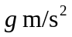where 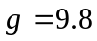
Students may bring up to two A4 pages of pre-written notes into the exam.
Formula sheets can be found on pages 20-22 of this exam.

This paper has been prepared independently of the Victorian Curriculum and Assessment Authority to provide additional exam preparation for students. Although references have been reproduced with permission of the Victorian Curriculum and Assessment Authority, the publication is in no way connected with or endorsed by the Victorian Curriculum and Assessment Authority.

© THE HEFFERNAN GROUP 2001
This Trial Exam is licensed on a non transferable basis to the purchaser. It may be copied for educational use within the school which has purchased it. This license does not permit distribution or copying of this Trial Exam outside that school or by any individual purchaser.
Part I

Question 1

The equations of the asymptotes to the curve with equation 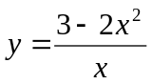 are

A. 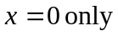
B. 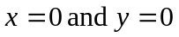
C. 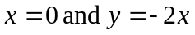
D. 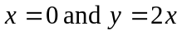
E. 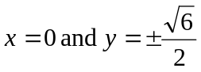

Question 2

The hyperbola with equation 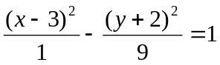 has its centre and its asymptotes given respectively by

A.
B.
C.
D.
E.

Question 3

For the function f, with rule 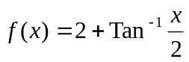, the implied domain is

A. 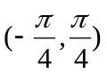
B. 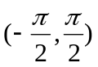
C. 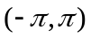
D. 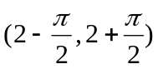
E. 
Question 4

If 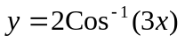 then 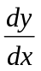 is equal to

A. 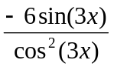
B. 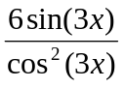
C. 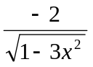
D. 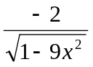
E. 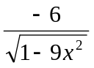

Question 5

The Argand diagram below shows the complex number z.

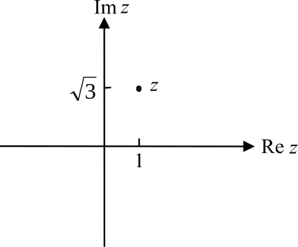

This complex number z is given by

A. 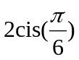
B. 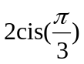
C. 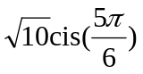
D. 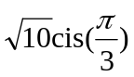
E. 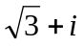
Question 6

If 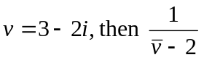 is equal to

A. 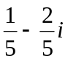
B. 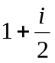
C. 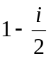
D. 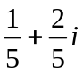
E. 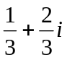

Question 7

If 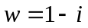 then 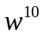 is equal to

A. 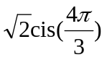
B. 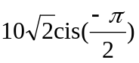
C. 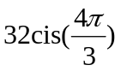
D. 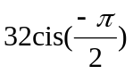
E. 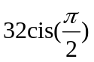

Question 8

For any complex number z, where 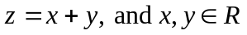, it is true to say that 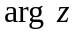 is equal to

A. 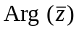
B. 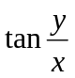
C. 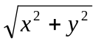
D. 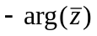
E. 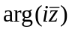
Question 9

Which one of the following sets of points in the Complex plane forms a curve?

A. 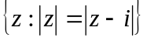
B. 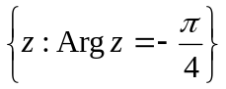
C. 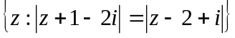
D. 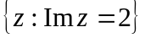
E. 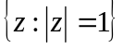

Question 10

An antiderivative of 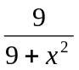 is

A. 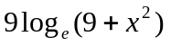
B. 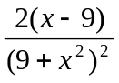
C. 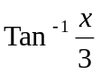
D. 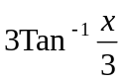
E. 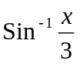

Question 11

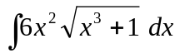 is equal to

A. 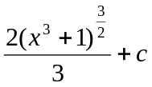
B. 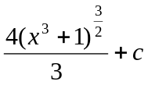
C. 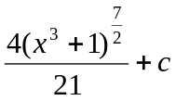
D. 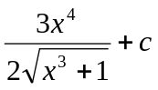
E. 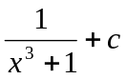
Question 12
Using an appropriate substitution, 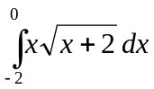 becomes
A. 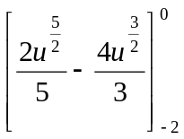
B. 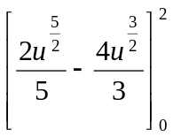
C. 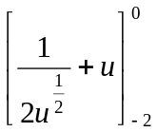
D. 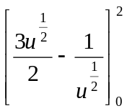
E. 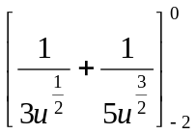

Question 13
Given that 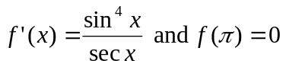, then 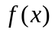 is equal to

A. 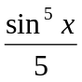
B. 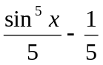
C. 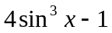
D. 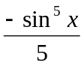
E. 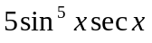

Question 14
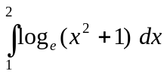 is, correct to 2 decimal places, equal to

A. –1.17
B. –0.51
C. 0.51
D. 1.16
E. 1.17
Question 15

The approximate value of 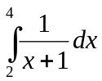, obtained by using the trapezoidal rule with 2 equal intervals is

A. 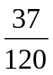
B. 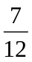
C. 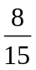
D. 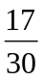
E. 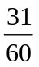

Question 16

Given that 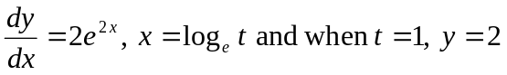, then the function 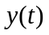 is given by

A. 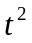
B. 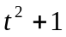
C. 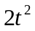
D. 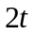
E.

Question 17

The differential equation 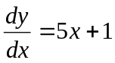 where 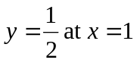 is solved using Euler’s method with a step size of 0.1.
The value found for at 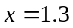 is

A. 0.6
B. 0.83
C. 1.9
D. 2.45
E. 2.725
Question 18

The graph of 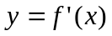 is shown below.

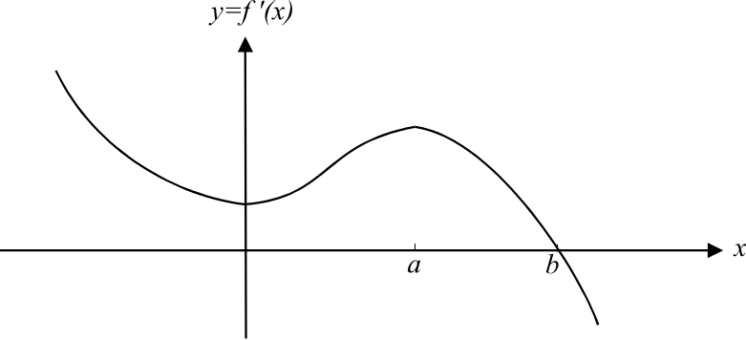

Which one of the following graphs could be the graph of ?

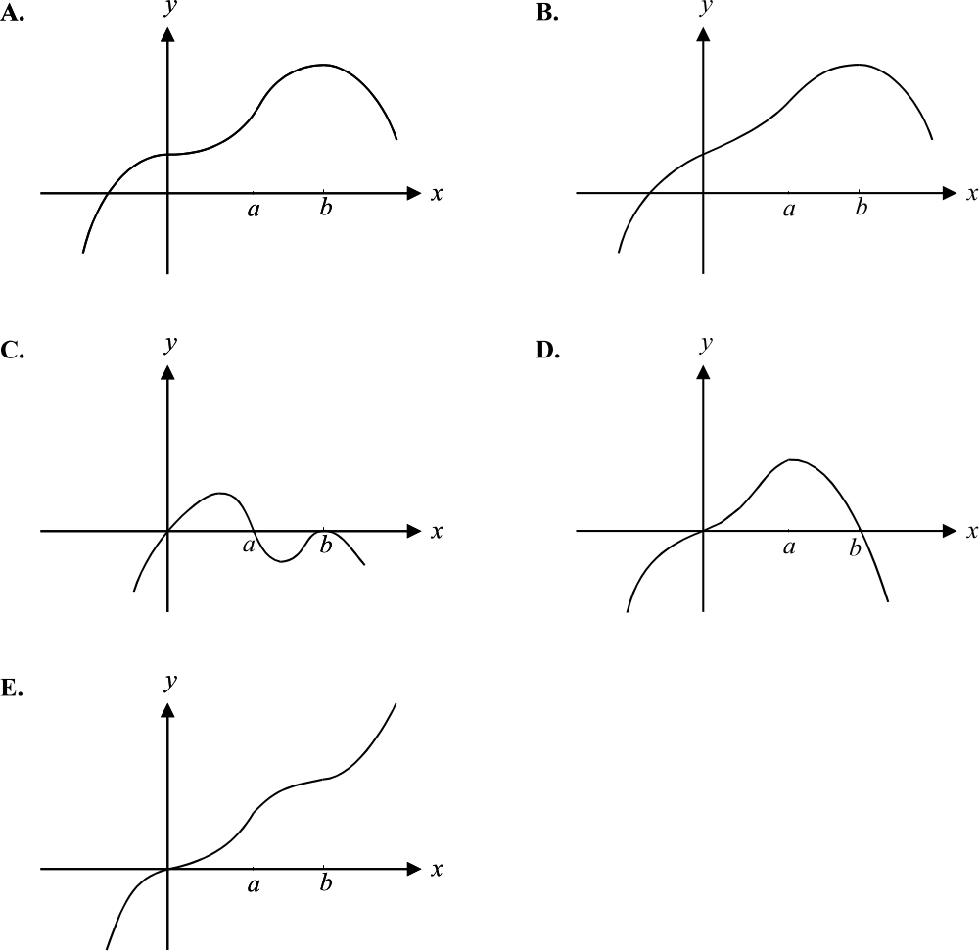

Question 19
The region enclosed by the graphs of , is rotated around the x-axis. The volume of the solid of revolution formed is given by
A. 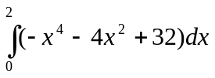
B. 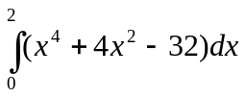
C. 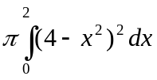
D. 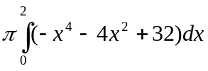
E. 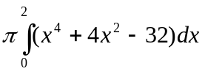

Question 20
The velocity-time function of a particle is given by
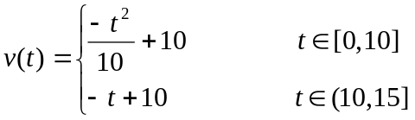
The velocity –time graph is shown below.
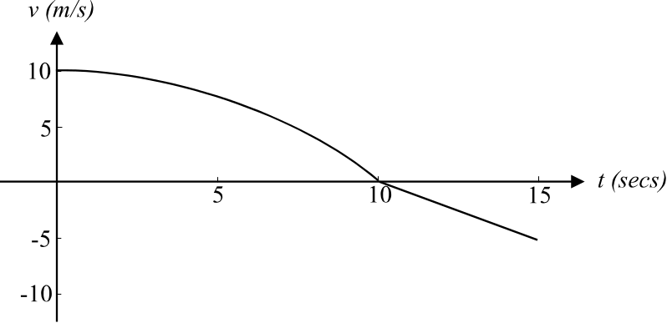

The displacement of the particle over the interval 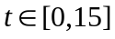 is given by
A. 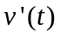
B. 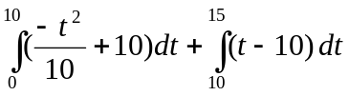
C. 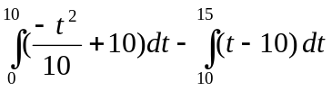
D. 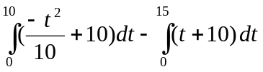
E. 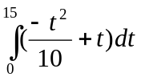
Question 21

The position vector of point P is 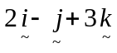 and the position vector of point Q is 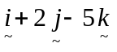.
The magnitude of 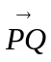 is

A. 1
B. 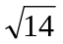
C. 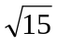
D. 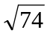
E. 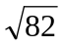

Question 22

A cattleman leaves a hut at point O and rides on a bearing of 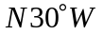 for 12 km to a second hut at point P. If 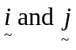 are unit vectors of magnitude 1 km in the directions east and north respectively, then 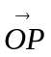 is given by

A. 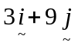
B. 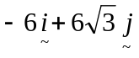
C. 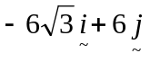
D. 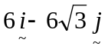
E. 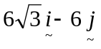

Question 23

The angle between the vectors 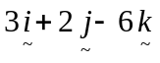 and 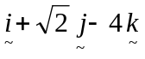, to the nearest minute is
A. 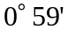
B. 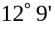
C. 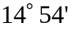
D. 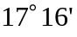
E. 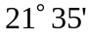
Question 24

Let 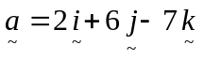 and 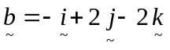. The vector component of perpendicular to is

A.
B. 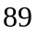
C. 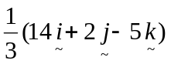
D. 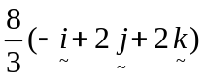
E. 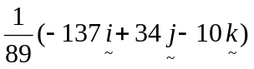

Question 25

The position vector of a particle at time t is given by

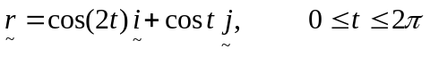

The path along which the particle moves has 2 endpoints. The Cartesian coordinates of those endpoints are

A. (1, 1) and (1, -1)
B. (1, -1) and (-1, -1)
C. (1, 1) and (-1, 0)
D. (-1, 0) and (1, -1)
E. (-1, 1) and (1, 0)

Question 26

A particle of mass 2kg sits on a smooth level surface and is at rest. A horizontal force of
100 N then acts on the particle. The number of seconds it will take for the particle to be moved 10 m is

A. 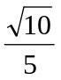
B. 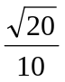
C.
D.
E. 
Question 27

An object of mass 2 kg is moving in a straight line. The velocity of the body is initially 12 m/s but increases to 15 m/s over a 3 second interval.
The change of momentum of the particle in kg m/s, in the direction of its established motion is

A. –6
B. –1
C. 2
D. 3
E. 6

Question 28

A mass of 20 kg is suspended in equilibrium by two strings of length 6 m and 8 m which are attached to a horizontal ceiling at 2 points which are 10 m apart.
The tension, in Newtons, in the shorter string is

A. 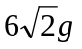
B. 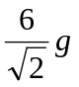
C. 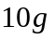
D. 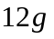
E. 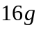

Question 29

A woman of mass 50 kg stands in a lift which is moving upwards with an acceleration of 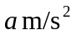. The floor of the lift exerts a force of magnitude 75g Newtons on the woman.
The value of a is

A. 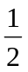
B. 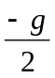
C. 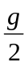
D. 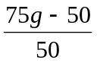
E. 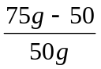
Question 30

Two weights, one of mass 5 kg and one of mass 7 kg, are attached to either end of a light inextensible string which passes over a smooth pulley. The system is shown below.

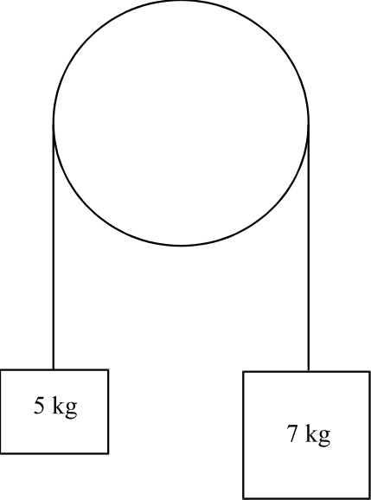

The weights are held in place and then released.
If T is the tension force in the string, then the acceleration of the 7 kg mass can be given by

A. 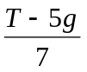
B. 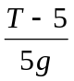
C. 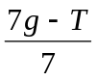
D. 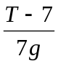
E. 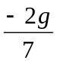
Part II

Question 1

Sketch the graph of 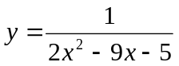 on the set of axes below.
Indicate clearly any asymptotes. State, correct to 2 decimal places, the coordinates of any turning points or intercepts.

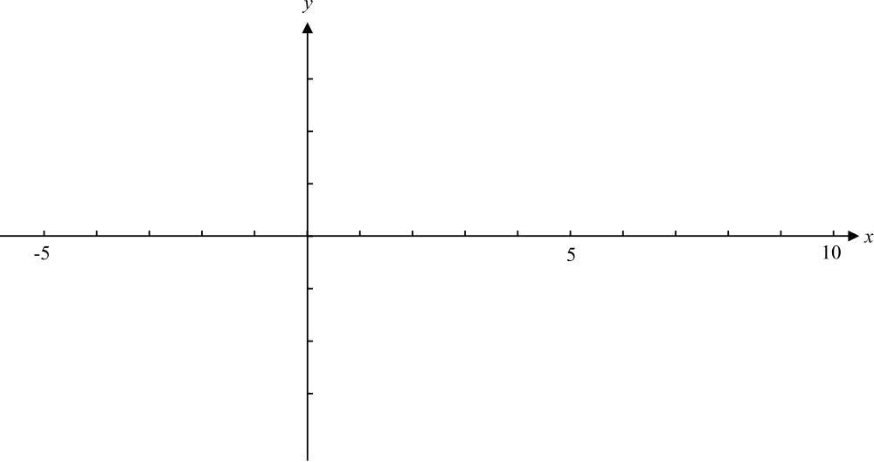

4 marks
Question 2

ABCD is a square. W, X, Y and Z are the midpoints of sides AB, BC, CD and DA respectively and 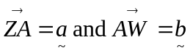.

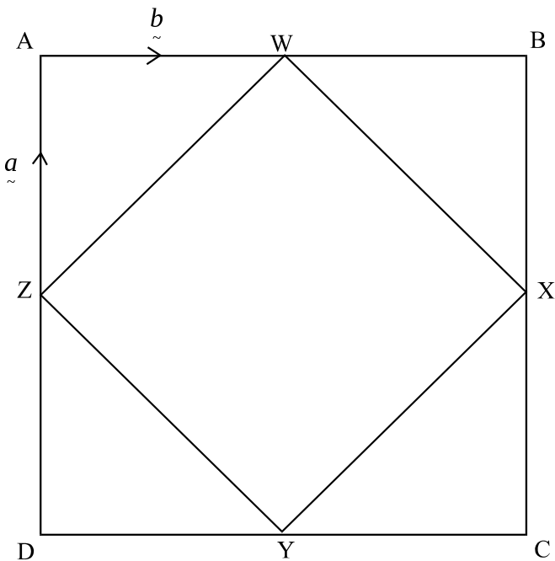

Show that WXYZ is a square.

___________________________________________________________________________

___________________________________________________________________________

___________________________________________________________________________

___________________________________________________________________________

___________________________________________________________________________

___________________________________________________________________________

___________________________________________________________________________

___________________________________________________________________________

___________________________________________________________________________

___________________________________________________________________________

___________________________________________________________________________
3 marks
Question 3

A toy box of mass 5 kg is resting on a rough level floor which has a coefficient of friction
of 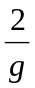. A child applies a horizontal force of 8 Newtons to the box.
Explain whether or not the child will cause the toy box to move across the floor.

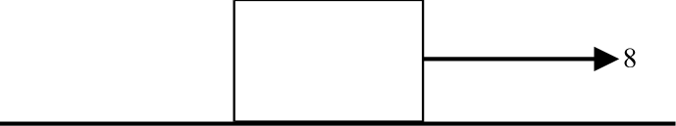

___________________________________________________________________________

___________________________________________________________________________

___________________________________________________________________________

___________________________________________________________________________

___________________________________________________________________________

___________________________________________________________________________

___________________________________________________________________________

___________________________________________________________________________

___________________________________________________________________________

___________________________________________________________________________

___________________________________________________________________________

___________________________________________________________________________

___________________________________________________________________________
3 marks
Question 4

a. Find the value of k for which 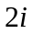 is a solution to the equation

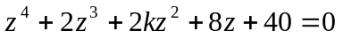.

____________________________________________________________________

____________________________________________________________________

____________________________________________________________________

____________________________________________________________________

____________________________________________________________________

____________________________________________________________________

____________________________________________________________________
1 mark

b. Hence find the other solutions to the equation.

____________________________________________________________________

____________________________________________________________________

____________________________________________________________________

____________________________________________________________________

____________________________________________________________________

____________________________________________________________________

____________________________________________________________________

____________________________________________________________________

____________________________________________________________________

____________________________________________________________________

____________________________________________________________________
2 marks
Question 5

Use calculus to find the exact area of the region bounded by the graph of the equation 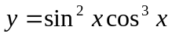, the x-axis and the lines 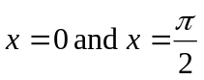.

___________________________________________________________________________

___________________________________________________________________________

___________________________________________________________________________

___________________________________________________________________________

___________________________________________________________________________

___________________________________________________________________________

___________________________________________________________________________

___________________________________________________________________________

___________________________________________________________________________

___________________________________________________________________________

___________________________________________________________________________

___________________________________________________________________________

___________________________________________________________________________

___________________________________________________________________________

___________________________________________________________________________

___________________________________________________________________________

___________________________________________________________________________
3 marks
Question 6

A particle of mass1 kg is dropped from rest from the top of a tower and falls vertically, experiencing air resistance of 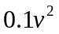. Now, 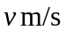 represents the velocity of the particle, x m represents the position of the particle in relation to the top of the tower and g 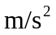 represents the acceleration due to gravity.

a. Taking the downwards direction as positive, show that
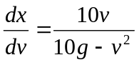

____________________________________________________________________

____________________________________________________________________

____________________________________________________________________

____________________________________________________________________

____________________________________________________________________

____________________________________________________________________

____________________________________________________________________
1 mark

b. Find the distance below the top of the tower for which the velocity of the particle is
1 m/s.
Express your answer correct to 2 significant figures.

____________________________________________________________________

____________________________________________________________________

____________________________________________________________________

____________________________________________________________________

____________________________________________________________________

____________________________________________________________________

____________________________________________________________________

____________________________________________________________________

____________________________________________________________________

____________________________________________________________________

____________________________________________________________________
3 marks
Total 20 marks

Specialist Mathematics Formulas
Specialist Mathematics Formulas

Mensuration

area of a trapezium:
curved surface area of a cylinder:
volume of a cylinder:
volume of a cone:
volume of a pyramid:
volume of a sphere:
area of a triangle:
sine rule:
cosine rule:

Coordinate geometry

ellipse:
hyperbola:

Circular (trigonometric) functions

function
domain

range

Reproduced with permission of the Victorian Curriculum and Assessment Authority.

Algebra (Complex numbers)

(de Moivre’s theorem)

Calculus

product rule:
quotient rule:
chain rule:

Reproduced with permission of the Victorian Curriculum and Assessment Authority.

mid-point rule:
trapezoidal rule:
Euler’s method:

acceleration:
constant (uniform) acceleration:

Vectors in two and three dimensions

Mechanics

momentum:
equation of motion:
friction:

Reproduced with permission of the Victorian Curriculum and Assessment Authority.
(Taken from Issue 156 of the Bulletin.)

